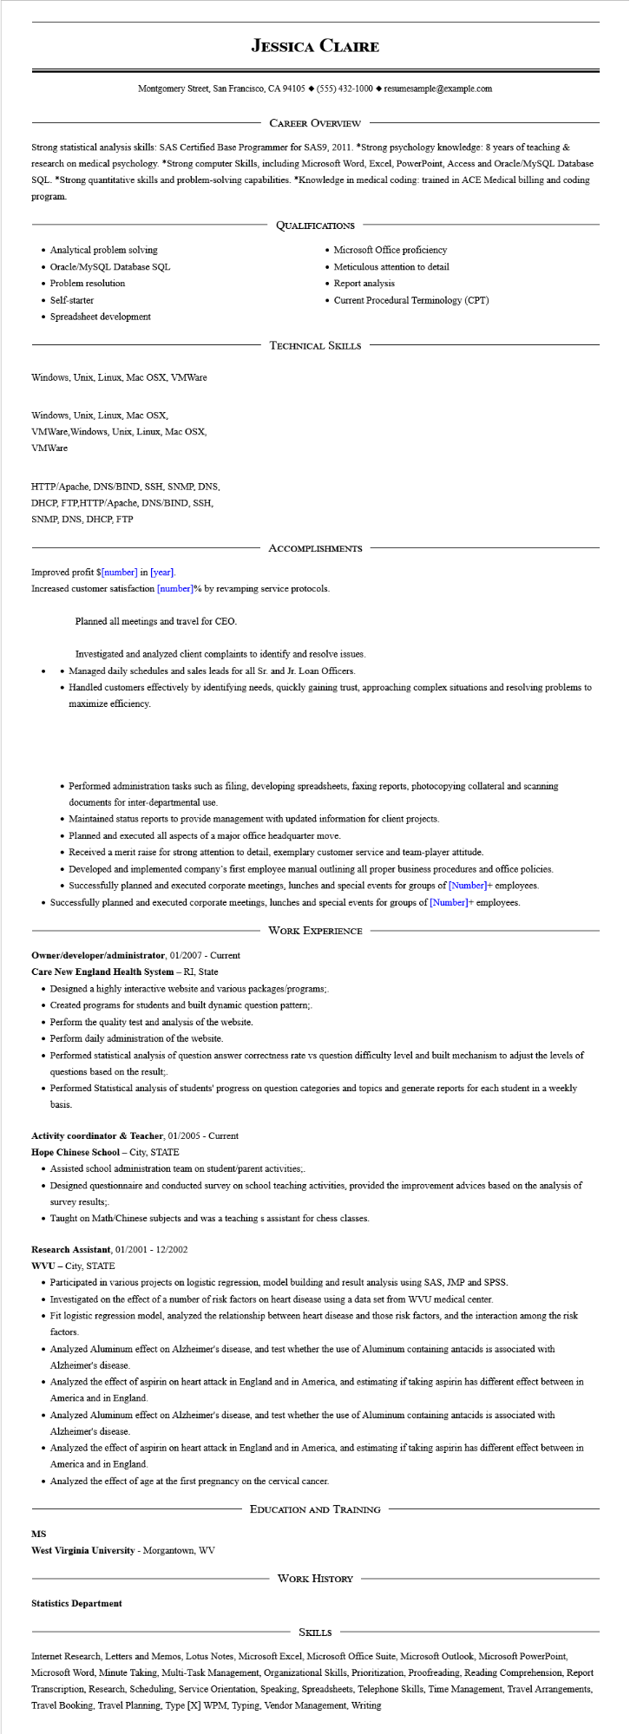
JESSICA CLAIRE
Montgomery Street, San Francisco, CA 94105 ♦ (555) 432-1000 resumesample@example.com
CAREER OVERVIEW
Strong statistical analysis skills: SAS Certified Base Programmer for SAS9, 2011. *Strong psychology knowledge: 8 years of teaching & research on medical psychology. *Strong computer Skills, including Microsoft Word, Excel, PowerPoint, Access and Oracle/MySQL Database SQL. *Strong quantitative skills and problem-solving capabilities. *Knowledge in medical coding: trained in ACE Medical billing and coding program.
• Analytical problem solving
• Oracle/MySQL Database SQL
• Problem resolution
• Self-starter
• Spreadsheet development
QUALIFICATIONS
• Microsoft Office proficiency
• Meticulous attention to detail
• Report analysis
• Current Procedural Terminology (CPT)
Windows, Unix, Linux, Mac OSX, VMWare
Windows, Unix, Linux, Mac OSX,
VMWare, Windows, Unix, Linux, Mac OSX, VMWare
HTTP/Apache, DNS/BIND, SSH, SNMP, DNS,
DHCP, FTP,HTTP/Apache, DNS/BIND, SSH, SNMP, DNS, DHCP, FTP
Improved profit $[number] in [year].
TECHNICAL SKILLS
ACCOMPLISHMENTS
Increased customer satisfaction [number]% by revamping service protocols.
Planned all meetings and travel for CEO.
Investigated and analyzed client complaints to identify and resolve issues.
• Managed daily schedules and sales leads for all Sr. and Jr. Loan Officers.
• Handled customers effectively by identifying needs, quickly gaining trust, approaching complex situations and resolving problems to maximize efficiency.
• Performed administration tasks such as filing, developing spreadsheets, faxing reports, photocopying collateral and scanning documents for inter-departmental use.
• Maintained status reports to provide management with updated information for client projects.
• Planned and executed all aspects of a major office headquarter move.
• Received a merit raise for strong attention to detail, exemplary customer service and team-player attitude.
• Developed and implemented company's first employee manual outlining all proper business procedures and office policies.
• Successfully planned and executed corporate meetings, lunches and special events for groups of [Number]+ employees.
• Successfully planned and executed corporate meetings, lunches and special events for groups of [Number]+ employees.
WORK EXPERIENCE
Owner/developer/administrator, 01/2007 - Current
Care New England Health System - RI, State
• Designed a highly interactive website and various packages/programs;.
• Created programs for students and built dynamic question pattern;.
• Perform the quality test and analysis of the website.
• Perform daily administration of the website.
• Performed statistical analysis of question answer correctness rate vs question difficulty level and built mechanism to adjust the levels of questions based on the result;.
• Performed Statistical analysis of students' progress on question categories and topics and generate reports for each student in a weekly basis.
Activity coordinator & Teacher, 01/2005 - Current
Hope Chinese School - City, STATE
• Assisted school administration team on student/parent activities;.
• Designed questionnaire and conducted survey on school teaching activities, provided the improvement advices based on the analysis of survey results;.
• Taught on Math/Chinese subjects and was a teaching s assistant for chess classes.
Research Assistant, 01/2001 - 12/2002
WVU City, STATE
• Participated in various projects on logistic regression, model building and result analysis using SAS, JMP and SPSS.
• Investigated on the effect of a number of risk factors on heart disease using a data set from WVU medical center.
• Fit logistic regression model, analyzed the relationship between heart disease and those risk factors, and the interaction among the risk factors.
• Analyzed Aluminum effect on Alzheimer's disease, and test whether the use of Aluminum containing antacids is associated with Alzheimer's disease.
• Analyzed the effect of aspirin on heart attack in England and in America, and estimating if taking aspirin has different effect between in America and in England.
• Analyzed Aluminum effect on Alzheimer's disease, and test whether the use of Aluminum containing antacids is associated with Alzheimer's disease.
• Analyzed the effect of aspirin on heart attack in England and in America, and estimating if taking aspirin has different effect between in America and in England.
• Analyzed the effect of age at the first pregnancy on the cervical cancer.
MS
West Virginia University - Morgantown, WV
Statistics Department
EDUCATION AND TRAINING
WORK HISTORY
SKILLS
Internet Research, Letters and Memos, Lotus Notes, Microsoft Excel, Microsoft Office Suite, Microsoft Outlook, Microsoft PowerPoint, Microsoft Word, Minute Taking, Multi-Task Management, Organizational Skills, Prioritization, Proofreading, Reading Comprehension, Report Transcription, Research, Scheduling, Service Orientation, Speaking, Spreadsheets, Telephone Skills, Time Management, Travel Arrangements, Travel Booking, Travel Planning, Type [X] WPM, Typing, Vendor Management, Writing

